**India’s Agriculture crop Analysis**

**1. Introduction**

**1.1 Over view:**

* Technology based crop recommendation system for agriculture helps the farmers to increase the crop yield by recommending a suitable crop for their land with the help of geographic and the climatic parameters. India’s agriculture crop analysis project is followed by given title

**1.2Purpose:**

* .This project focuses on predicting crop yield while using machine learning techniques. Farmers can use this system to make decisions on what should be grown in the field.

**2. Problem statement & Design thinking**

* Unreliable rainfall
* Lack of irrigation facilities
* Soil erosion
* Methods of cultivation
* Faulty cultivation of crops
* Reduction in net sown

**Solution**

* Generating employment opportunities
* Reducing risks in agriculture
* Developing agri-infrastructure
* Improving quality of rural life

**2.1 Empathy map:**

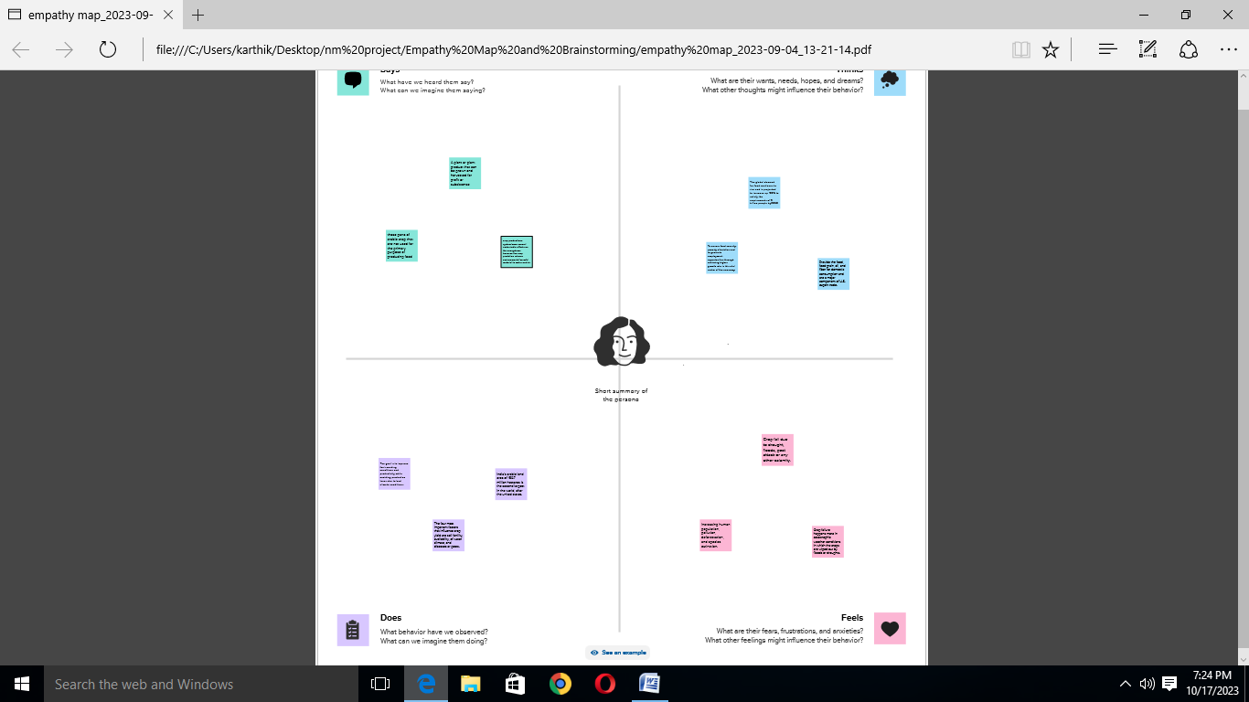

**2.1 Brainstorming map:**

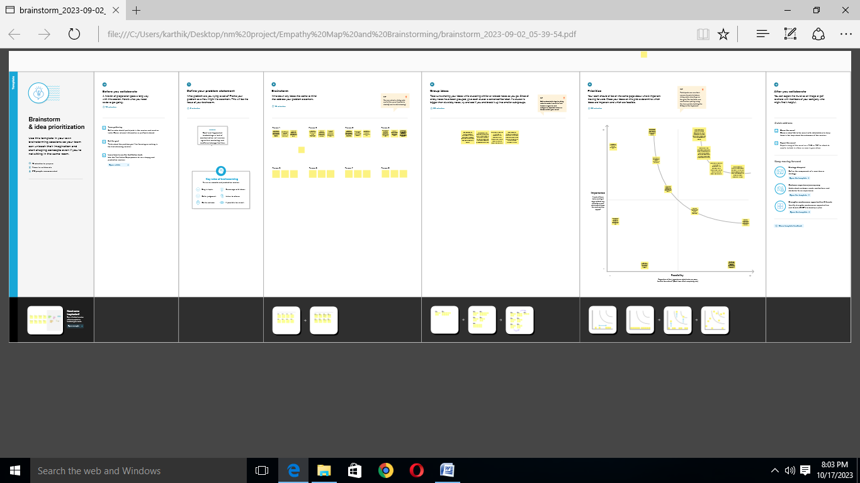

**3. Result:**

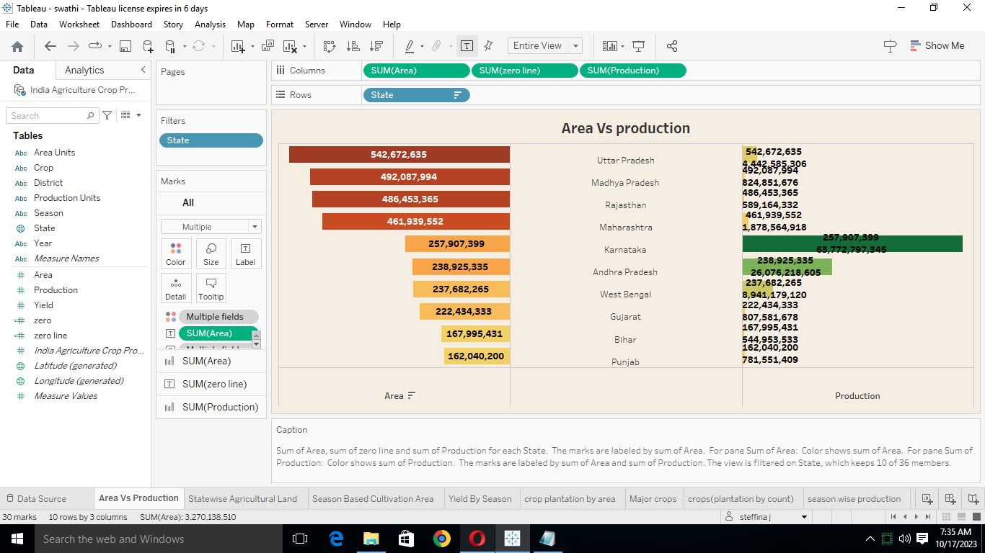

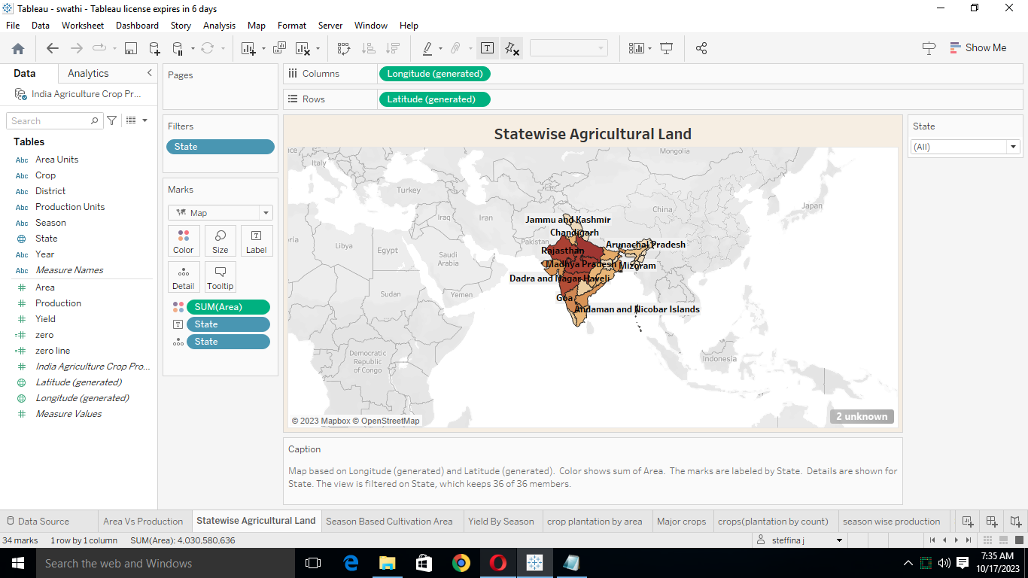

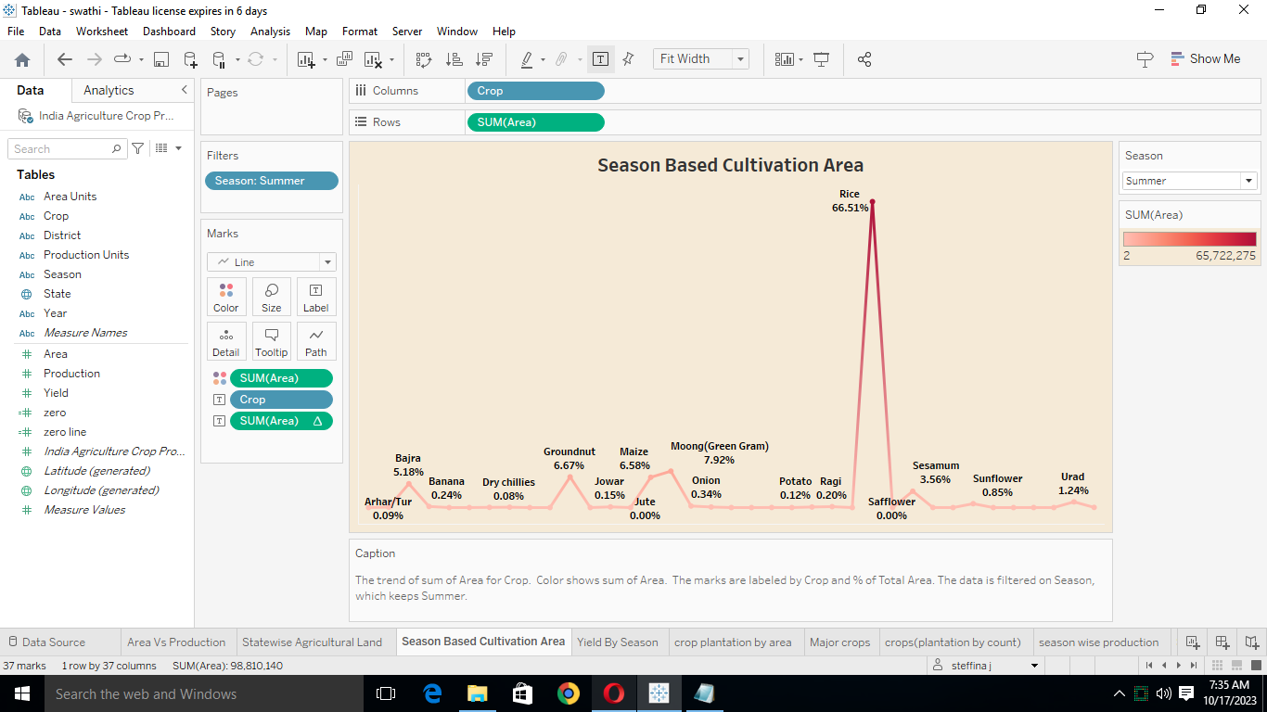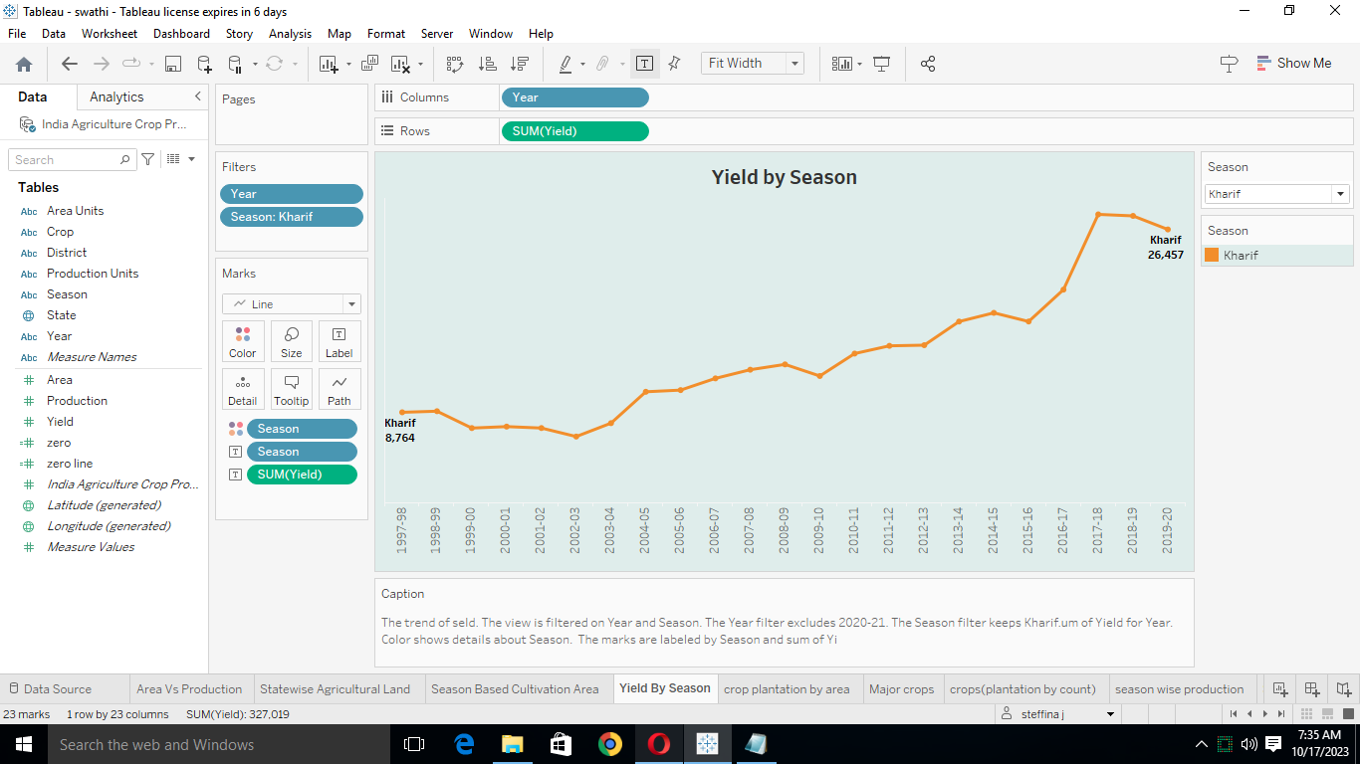

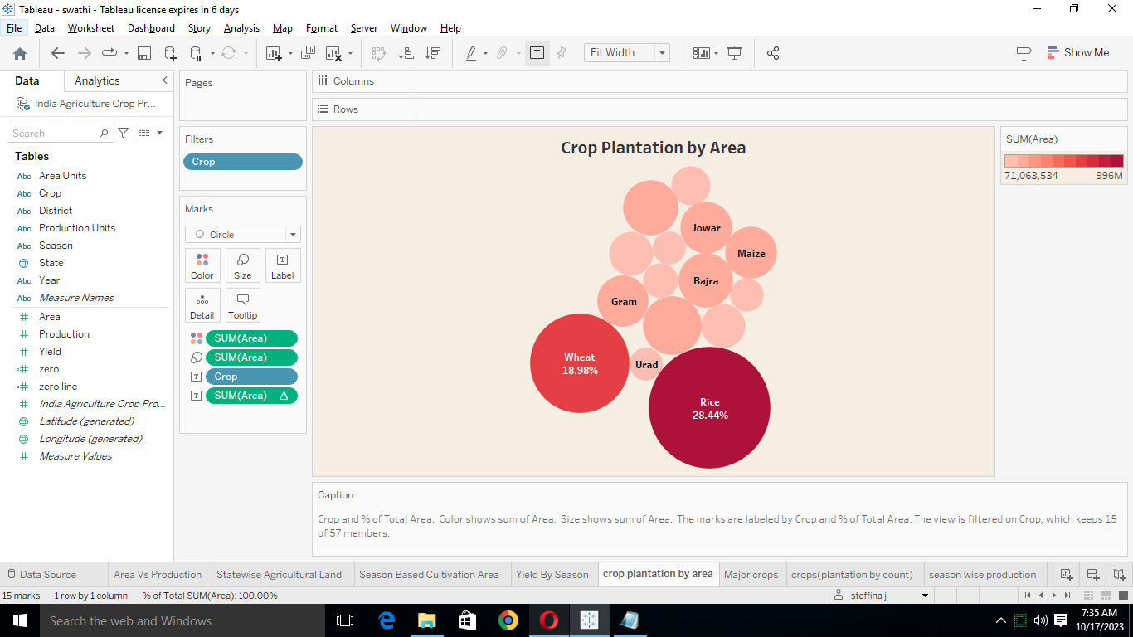

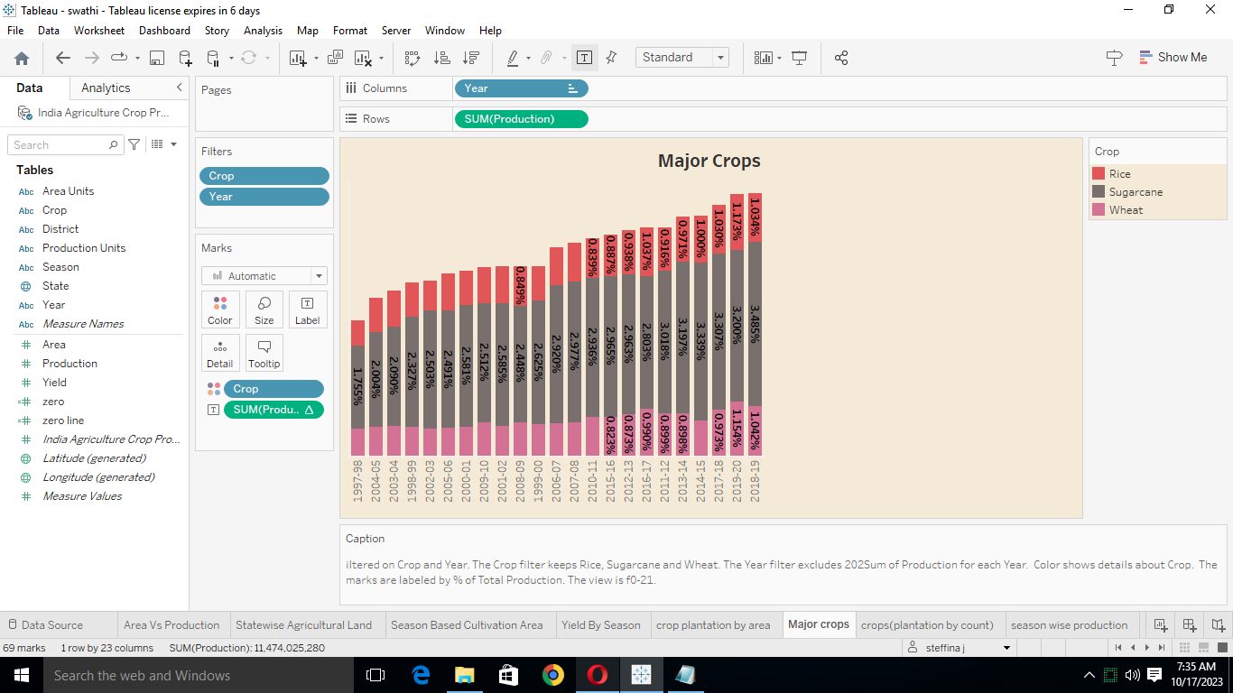

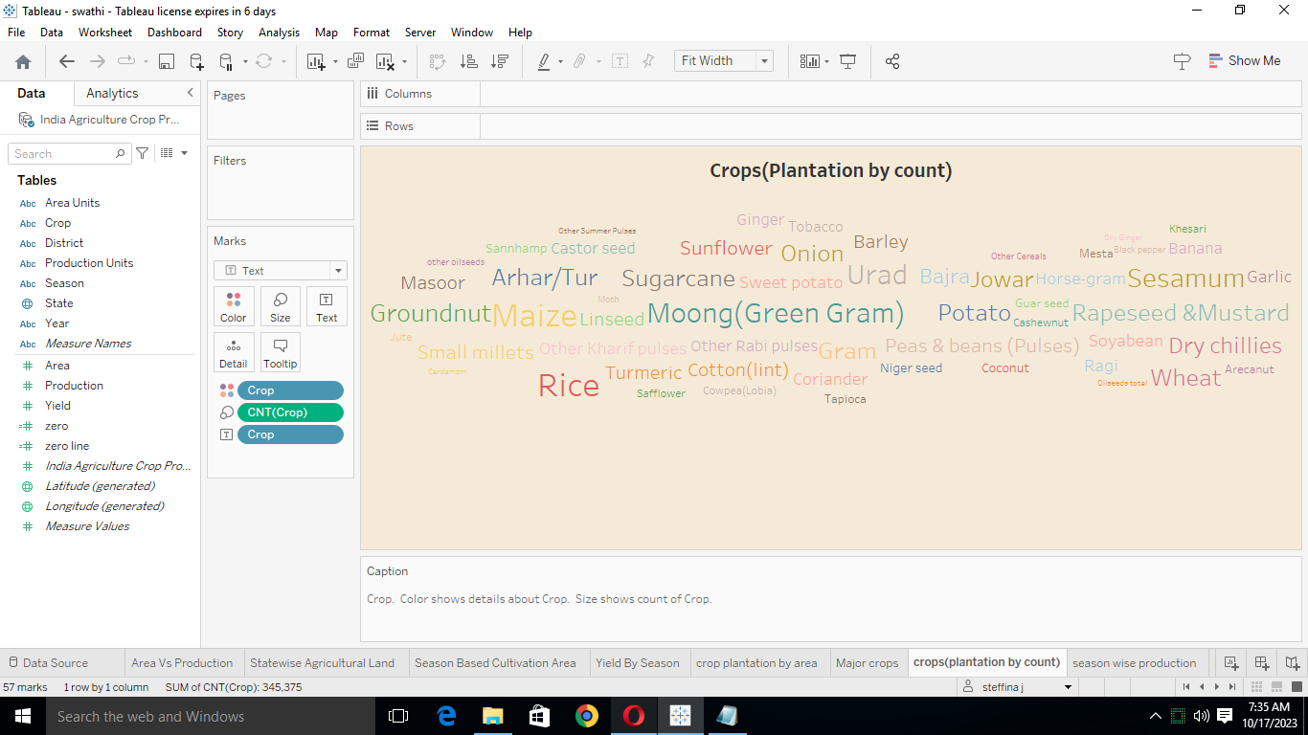

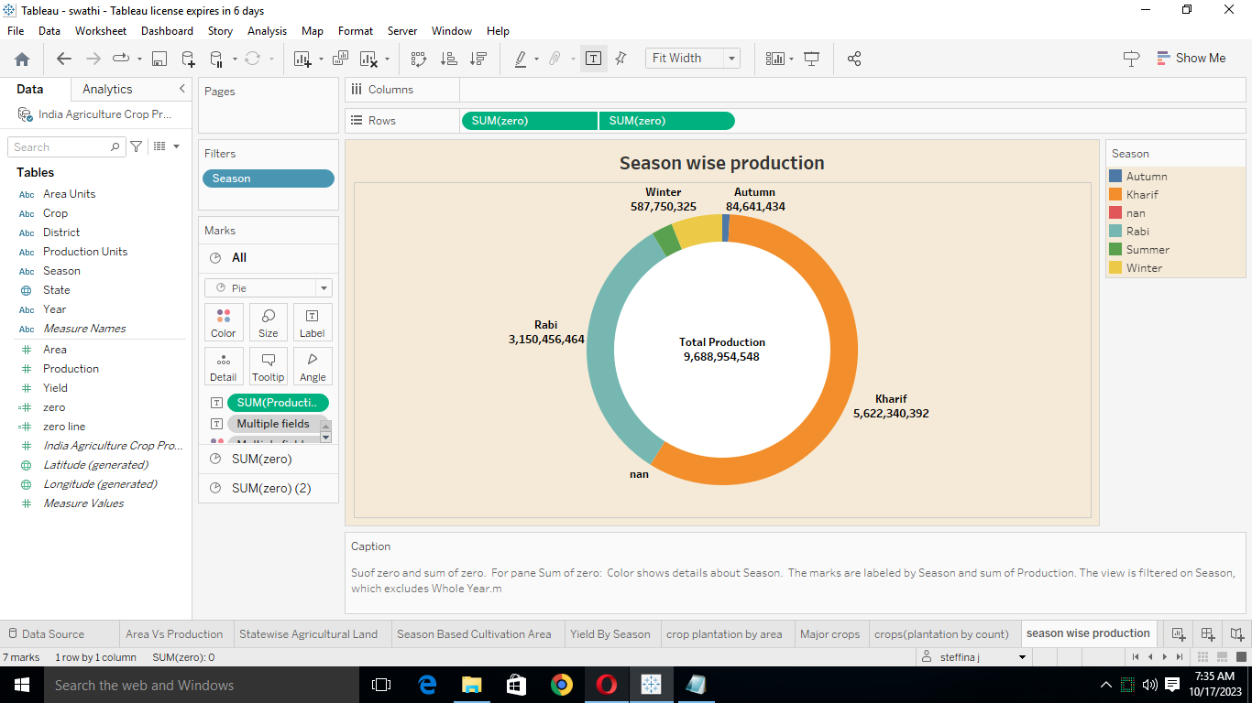

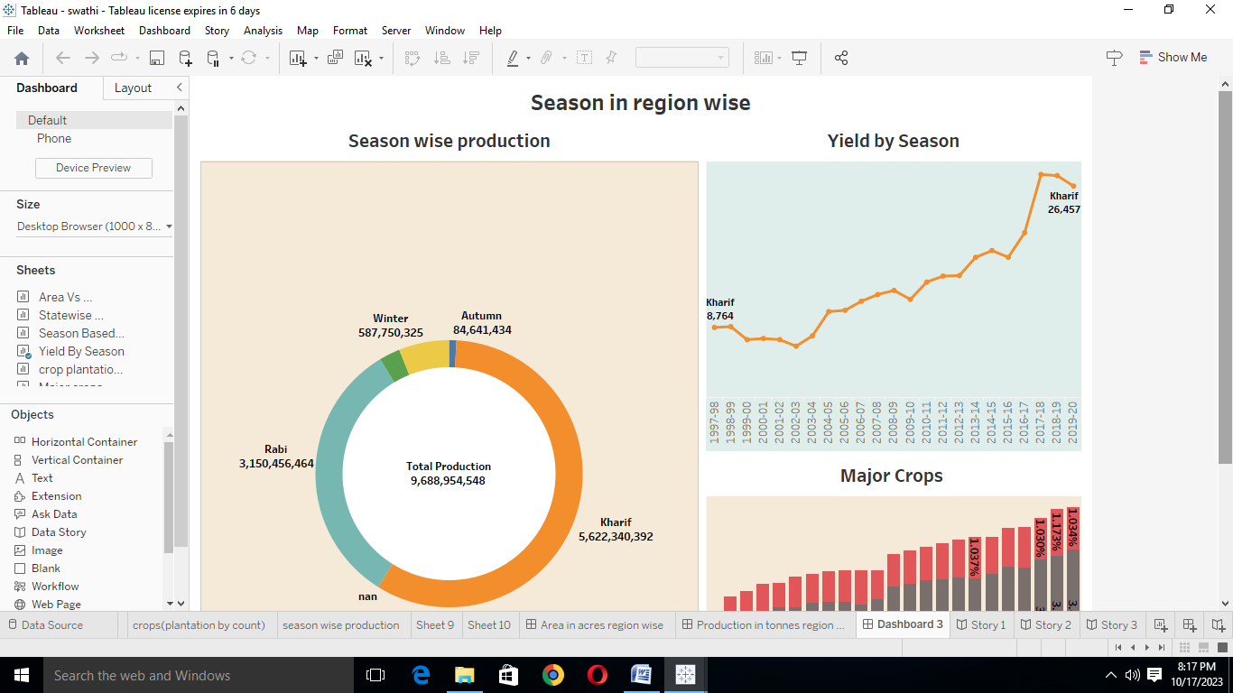

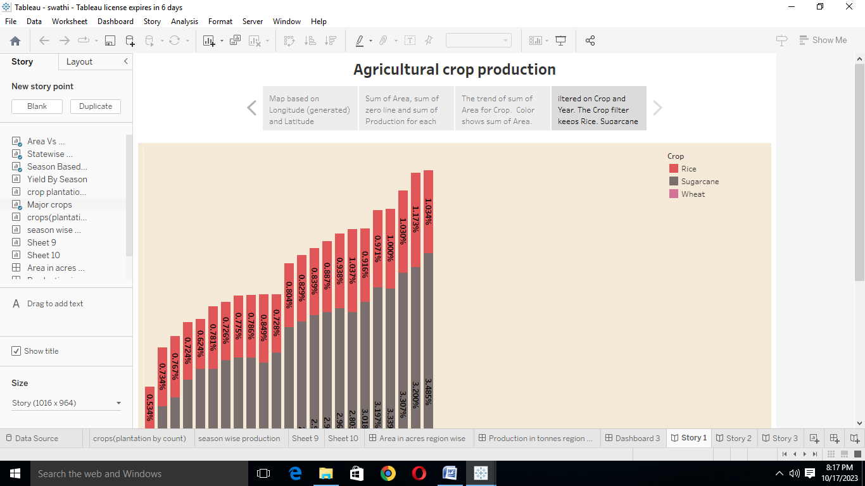

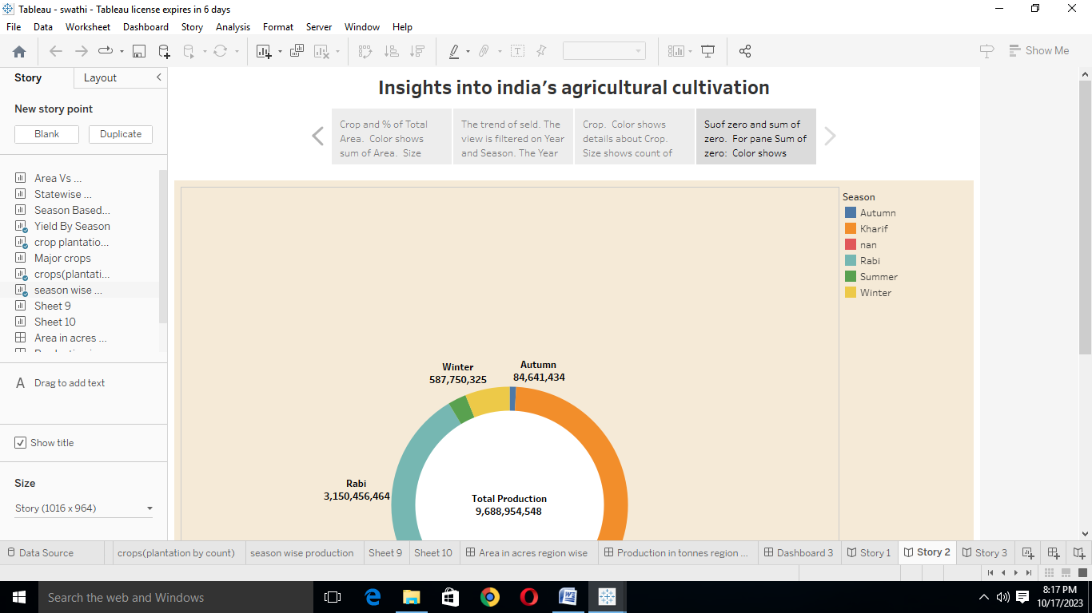

**4. Advantages:**

* To increase quality and yields, it is crucial to understand the current nutrient levels of the soil to be able to ascertain which area require improvement.

**Disadvantages:**

* The present challenges that plague Indian agriculture are limited knowledge and insufficient infrastructure especially in the rural areas.

**5. Application:**

* Help ensure the profitability of their land while improving soil fertility, helping promote sound environmental practices, and minimizing environmental impacts through climate action for rural areas.

**6. Conclusion:**

This project has oriented by agriculture crop analysis in india. And then we have seen that worksheet, dashboard and story pages. In this, we should understand of importance of agriculture crop analysis.

**7. Future scope:**

* Use nano-technology for enhancement of food quality and safety, efficient use of input will be near future.
* Nano-materials in agriculture will reduce the wastage in use of chemicals, minimize nutrient losses in fertilization and will be used to increase yield through pest and nutrient management.